Think Small, Act Big: Fun Ways to Boost Local During Small Business Month

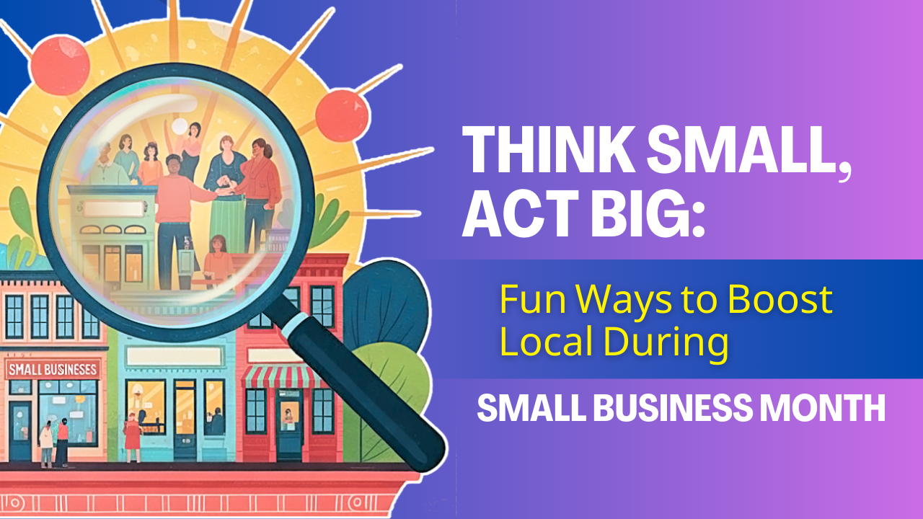

Another calendar page has come and gone and with it, we’re ushering in May and Small Business Month. There’s no better time to show some local love!

Small businesses are the heartbeat of our community. They’re the coffee shops where we meet friends, the boutiques that stock one-of-a-kind finds, and the service providers who remember our names and donate to our causes.

But before you think this is a new call to spend money, know that you don’t need a big budget to make a big impact.

**Every purchase (yes, there’s the money but wait…), referral, and review goes a long way toward helping small businesses thrive.**

Whether you have $5 or just five minutes, we have some creative, fun, and meaningful ways to support small businesses this month.

So get out into our community and support those who help make it what it is.

## Small Business Is a Big Deal

When we say support small business, most people think of our Main Street shops. But “small business” is any business that employs under 200 people.

Ask yourself what percentage of your weekly purchases are done with small businesses? Can you increase that percentage this month?

Make a list of where you currently do business. Pull out your credit or bank card transactions. See where your money is going and how that could change this month. For instance, if you visit Starbucks every day, try a local place on the weekends or swap Starbucks for local out completely for this month.

How does that feel?

But don’t stop there. There are a lot of things you can do that don’t cost a lot.

## 10 Fun Ways to Celebrate Small Business Month

### 1. Shop Small (and Share It!)

When you buy from a local business, snap a photo and tag them on social media. Your shoutout helps them reach new customers—and shows your support in a way that goes beyond the checkout counter. Plus, a picture is worth a thousand words, and maybe even a purchase or two.

### 2. Leave a Glowing Review

A five-star review on Google, Yelp, or Facebook can boost a business’s visibility and reputation. Take five minutes to write something kind about your favorite local shop or restaurant—it’s free, fast, and powerful.

### 3. Take the “Local Love Challenge”

Try to do one locally focused thing each day this week:

* Monday: Grab coffee from an indie café
* Tuesday: Tag a small business you love on Instagram
* Wednesday: Leave a review
* Thursday: Buy a gift from a local boutique
* Friday: Recommend a local service provider to a friend
* Saturday: Try a new-to-you local restaurant
* Sunday: Post a selfie at your favorite business add the hashtag #ShopLocal Or if you want a monthly challenge instead, vow to spend $20 locally at a business you’ve never tried before or attend an event at a local business.

### 4. Buy Gift Cards for Later

If you’re not ready to spend much now, consider buying a small gift card for a future visit—or to give as a birthday or thank-you gift. It gives businesses cash flow now and brings you (or someone else) joy later.

### 5. Host a “Small Biz Night Out”

Make a night of it! Plan dinner with friends at a local restaurant, pop into a few shops, and end with dessert from a neighborhood bakery. Bonus points if you post about your local adventure on social media!

### 6. Introduce a Local Business to a New Customer

Word-of-mouth is still gold. Bring a friend to your favorite store, create a video/reel review on TikTok or Instagram, or tag someone in a post who might love a business’ products or services. Your recommendation could bring in a future loyal customer.

### 7. Get Involved in Chamber Events

Check your local Chamber of Commerce calendar (like ours! [www.bertramchamber.com](http://www.bertramchamber.com)) for small business events this month— and more. These events are a great way to discover new businesses and show your support in person.

### 8. Support Local on Social

Can’t spend right now? That’s okay! Like (use the love emoji instead of just the thumbs up), share, or comment on small business posts. It only takes a second to post a sticker or an emoji as a comment. Help them beat the algorithm and reach more people. Engagement matters more than you think.

### 9. Ask Businesses What They Need

Sometimes the best way to help is to ask. Maybe they’re looking for volunteers, help spreading the word, or even someone to test a new product. Your time and skills could be just as valuable as a purchase.

### 10. Celebrate Them Loudly and Proudly

Know a small business owner doing great work? Celebrate them publicly! Write a LinkedIn or Facebook post recognizing their contribution. Gratitude is contagious—and so is support.

Small Business Month is more than a campaign, it’s a reminder that we all play a role in shaping the success and culture of our community.

So this May, let’s think small, act big, and show our favorite businesses just how much they mean to us.

Let us know how you’re supporting local this month—tag [BertramChamber] and use #ShopLocal[Bertram] so we can cheer you on!