Bertram Chamber of Commerce
Board of Directors
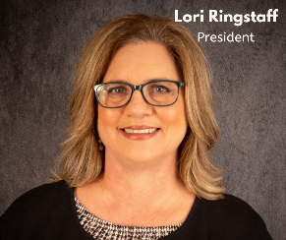
Lori is the Vice President and Business Development Officer at R Bank in Bertram. She has worked with the company since 2013. Previously, Lori worked at Farmers State Bank from 2003 until they were acquired by R Bank.
Currently, she is the president of the Bertram Chamber of Commerce, President of Bertram Economic Development Corporation, board chair for the Highland Lakes YMCA, and board member for Texas AgriLife Extension Service Leadership Advisory Board. Lori serves on many other committees and volunteer organizations and is active in both Burnet and Liberty Hill Chambers of Commerce.

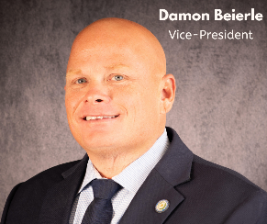
Damon was raised in Burnet, Tx and graduated from Burnet High School in 1996. He later married his high school sweetheart, Monica. Damon and Monica reside in Burnet where they are raising their two children, Tatum and Talon.
Damon is a long-time business owner in Burnet and currently serves as Burnet Country Commissioner for Precinct 2. For the past 17 years, he has served on the Board for the Burnet Chamber of Commerce. Damon is confident that he will utilize his experience to help the Bertram Chamber and its members as the community grows.

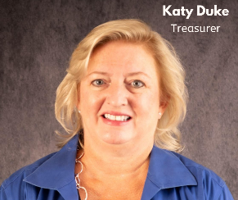
Katy is an experienced local REALTOR who works and lives in the Bertram area with her husband. Their son, Brice, is a BHS graduate and currently attends UT Dallas. The Dukes enjoy entertaining family and friends, traveling, and live music. Katy is passionate about Burnet County and the Central Texas area and enthusiastically supports the community. She has a background in business processes from her tenure at D & B and subsidiaries. Katy shares her business expertise and love for the area by serving in various civic organizations including the Chamber of Commerce and Bertram EDC. She also serves on the BCISD Board of Trustees.

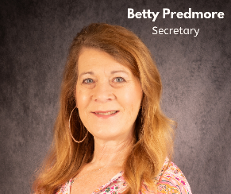
Betty is a Bertram transplant that is devoted to the community. She is the wife of Jim and mother of 7 and has a passion for the community and its people. Betty is a Christian counselor who operates a non-profit for women called Mom-Sense, Inc. She is a published author, conference/event speaker, and blogs for several online magazines.
In addition to serving on the board of the Bertram Chamber of Commerce, Betty has been an active member of the local festival committees, serves on the board of the Friends of the Bertram Library, and pens a weekly column in the Burnet Bulletin, Bits of Bertram, where she highlights the activities and events of Bertram.
After earning his bachelor’s, Andis worked for several municipalities in the parks & recreation field. He ended his municipal career after serving as the Parks & Recreation Director for the City of Smithville for 8 years. While in this role, he partnered with the Chamber and worked with several civic entities. During this time, he earned his MBA and volunteered at the fire department, where he earned his SFFMA Advanced Firefighter Certification and served as the Fire Marshall. Andis and his wife Whitney adopted 4 children and moved back to Burnet County, where Andis became a teacher for the BCISD before buying an insurance agency. In 2023, Andis merged his small agency with Rollo Insurance Group, which has over 60 locations across the U.S. Andis is currently the Associate over the Rollo branch in Bertram.

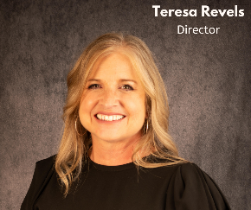
Teresa is passionate about family, faith, and serving in the community. She is the owner/agent of The Revels Family Agency, where she and her daughter Hannah enjoy educating and assisting community members with home, auto, life, Medicare, and commercial insurance. Bertram isn’t where she is from, but it is where she is thrilled to call home. You can usually find her enjoying a local winery with friends and family, hiking with her four-legged daughter Roxy, or enjoying time with her granddaughter. Teresa loves all things outdoors except snakes!

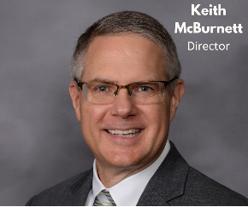
Keith has served in public education for over thirty years, and for the past 12 years has served as superintendent of schools of Burnet CISD. It was while teaching elementary school that he met his wife Pat, a now retired kindergarten teacher, and together they are the proud parents of Colin and Connor, who are both graduates of Burnet High School. Keith is proud to call Burnet County home and his passion for service goes beyond the school district as he is very involved in the community through his volunteer work.

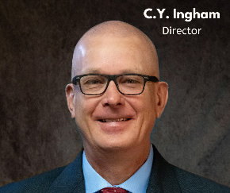
C.Y. has had a career in aerospace on programs including F-16 and F-35. He lives on a small farm in the Bertram area with his wife Stephanie. Since 2013 they enjoyed their farm as a weekend retreat until 2020 when they began living here full-time. They enjoy listening to live music, entertaining, and traveling. C.Y. likes being involved in the community and is proud to serve on the Bertram Chamber of Commerce.

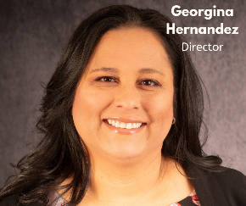
Georgina is the City Administrator for the City of Bertram. She is a graduate of Texas Tech University and is a Certified Municipal Clerk. Georgina started with the City of Lubbock in 1996 before coming to work for the City of Bertram in 2010. Her and her husband David live in Bertram with their 2 daughters. Georgina is currently a board member of the Bertram Municipal Development District, Texas Municipal Cler Association Hill Country Chapter secretary, and BHS Booster president for the Highlandettes drill team. With over 25 years of experience in the Municipal government, she hopes to utilize her experiences to help support Bertram’s growth.

